 | SUMMER CAMP 2025- 69 PAPE JULY 2025 CONTACT: ANGELA 416-645-6000 x1112 or LORI 416-645-6000 x 3501
 | ** Please bring a lunch and two snacks daily and respect our nut-free policy/ changes will be noted daily Hours = 8:30 a.m. – 4:30 p.m. Cost = $125.00/week
 | Mon | Tue | Wed | Thu | Fri
WEEK  1 | JUNE 30  GROUP GAMES  GOING TO MORSE PARK  BRING SWIMWEAR & TOWEL  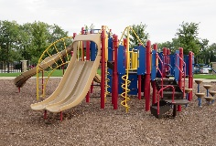  BINGO GAME (PM) | JULY 1  CLOSED  CANADA DAY   | JULY 2  TTC  Riverdale Farm Trip and Splash Pad CLIMBER  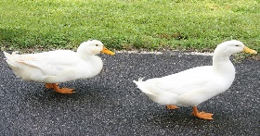  ARTS AND CRAFTS (PM) | JULY 3  Kew beach Park TTC  10:00-2:00  Bring swimwear and lunch  PLAYDOUGH AND  ARTS AND CRAFTS (PM) | JULY 4  BADMINTON GAME  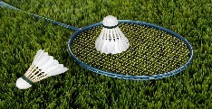  Creative Art / electronics  BOARD GAMES  COOKING ACTIVITY
WEEK  2 | JULY 7  Arts and Crafts / Chalk drawings  Scavenger hunt  JEWELLRY MAKING  MIND CHALLENGES  PLAYGROUND GAMES | JULY 8  10:00-1:30 WOODBINE PARK  TTC  BRING SWIMWEAR FOR SPLASH PAD | JULY 9  SOCCER game    COMPUTERS IN PM  LEGO CHALLENGE  Clay Art  SCOOP GAME | JULY 10  JONES PARK 10:00-2:00  BUBBLES  AND TAG FUN  SPLASH PAD  MINI GOLF COURSE | JULY 11  Movie/Pajama Day at Pape    MAKING NECKLACE WITH BEADS  MAKING FRUIT SALAD
WEEK 3 | JULY 14  CLAY CREATIONS  LEGO CLUB MAKING TALLEST STRUCTURES  CHALLENGE  SCIENTIST WORKSHOP   | JULY 15  Trip to the Movie Theatre  BRING TREATS Dodge Ball on Playground CARD GAMES ICE MOLD | JULY 16  LEGO LAND DISCOVERY CENTRE  BUS  VAUGHAN  Marshmallows Art  Bubbles  Bean bags toss challenge | JULY 17  FREEZE DANCE CHALLENGE  COOKING WORKSHOP  MAKING PIZZA 9:30-11:00 | July 18  Bring your own.  SHOW AND SHARE and Electronic Day  CARD GAMES  BINGO  COOKING  Hopscotch
WEEK 4 | JULY 21  COMPUTERS  LEGO FUN CONTEST  Art –MARBLE PAINTING  PLAYGROUND  SCIENCE FUN | JULY 22  10:00-2:00 SKYZONE-BUS  Badminton  Computers in pm | July 23  10-11:30 Baking cupcakes    PLAYGROUND SOCCER GAME  Make soda float | JULY 24 MORSE PARK  BUILDING SANDCASTLES  DECORATING CUPCAKES  BUBBLES  Scavenger hunt | JULY 25  Cupcake sale - $$$    Games/computers Making slime  LEGO  SUN MELTED CRAYONS ART

